AWS - LAMBDA
Steps Performed
1. Opened the AWS Lambda console and selected the function demo-lambda-function.
2. Navigated to the Code tab of the Lambda function.
3. Opened the lambda_function.py file in the inline code editor.
4. Modified the Lambda handler code to print a message and return a JSON response:
o Added a print() statement for log output.
o Configured a 200 status code with a response body.
5. Clicked Deploy to save and apply the code changes.
6. Confirmed the successful deployment message at the top of the console.
7. Clicked Test to execute the Lambda function.
8. Selected Create new test event from the test event dropdown.
9. Entered the test event name my_function_event.
10. Chose Synchronous invocation type
11. Set Event sharing to Private.
12. Selected the Hello World template for the test event.
13. Left the default Event JSON unchanged.
14. Clicked Save to create the test event.
15. Clicked Test again to invoke the Lambda function using the newly created test event.
16. Viewed the Execution results panel.
17. Verified the response output showing:
o StatusCode: 200
o Response body: "Hello from Lambda!"
18. Reviewed the logs output, including START, END, and REPORT entries.
19. Confirmed successful execution, execution duration, and memory usage details
Now give your information like fun.. name
Runtime …
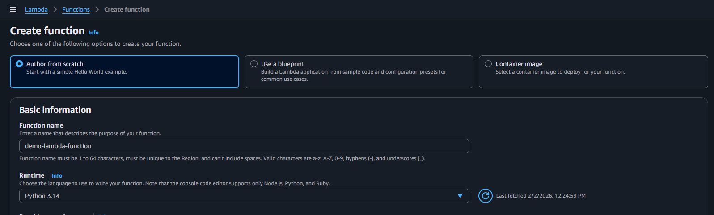

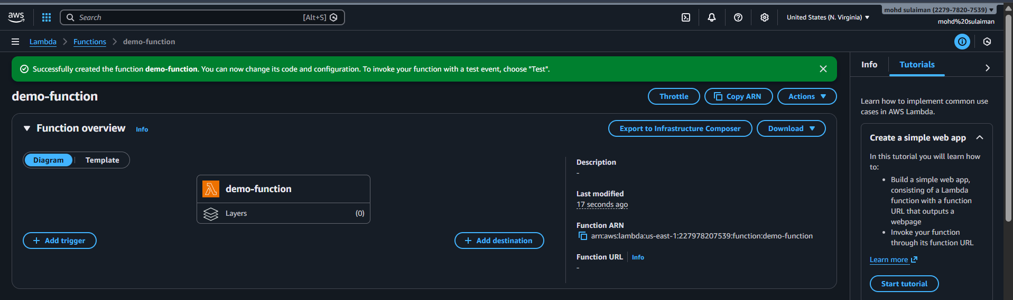
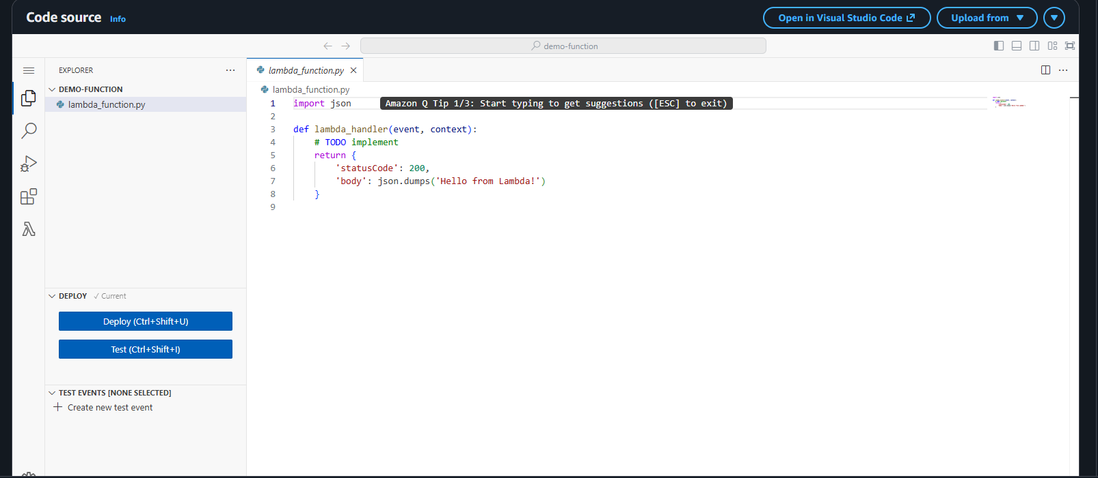
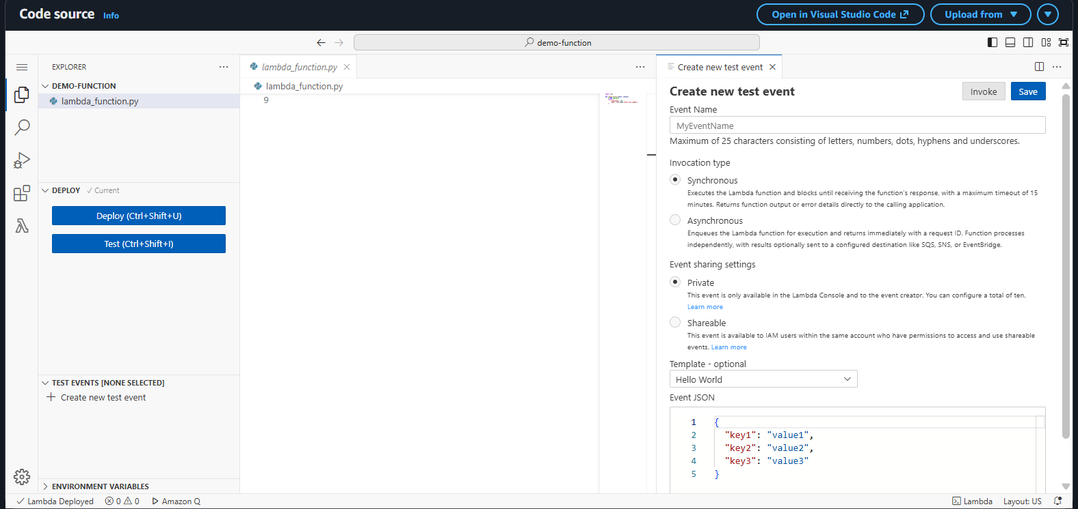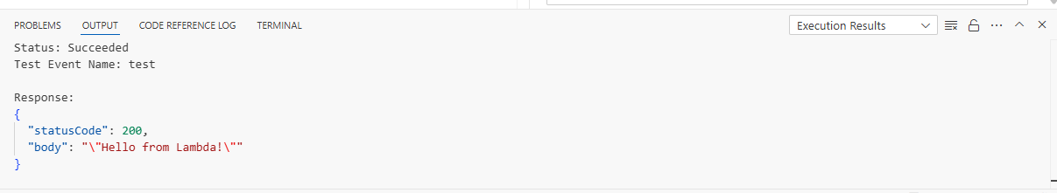
Steps Performed
1. Opened the AWS Lambda console and selected the function demo-lambda-function
2. Navigated to the Configuration tab of the Lambda function.
3. Clicked on Function URL from the left-side configuration menu.
4. Clicked Create function URL.
5. Selected Auth type: NONE to allow public access to the Lambda function.
6. Reviewed the automatically generated resource-based policy that allows public invocation of the function URL.
7. Proceeded with the default settings and created the Function URL.
8. Verified that the Function URL was successfully created and marked as public.
9. Copied the generated Lambda Function URL.
10. Opened a web browser and accessed the Lambda Function URL.
11. Observed the function response displayed in the browser:
“Hello from Lambda!”
12. Confirmed that the Lambda function was successfully invoked via the Function URL without authentication

